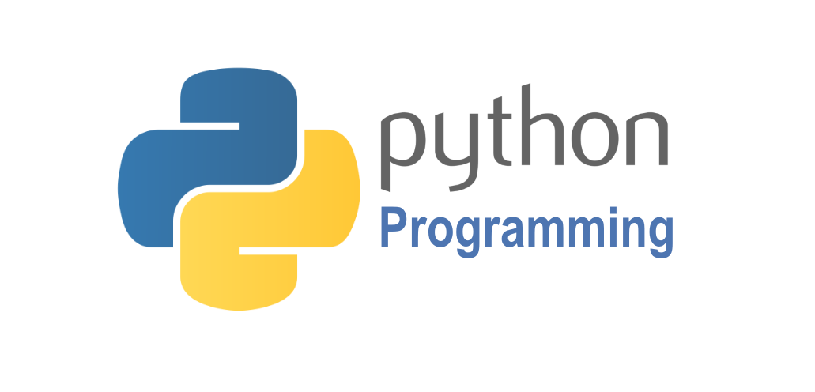

|  |  |
| --- | --- |
| -lecture 1         Python Installing          Comments          Input&Output          Variables & Constants          Data Types          Casting  Python Collections  Operators   -lecture 2 If Statement  Loop -lecture 3         String Functions          Number Functions          Arrays Functions          Lists Functions          Tuple Functions          Set Functions          Dictionary Functions | -lecture 4 Exercise  Functions  Class  try...catch -lecture 5 Flask - Route -lecture 6 Flask - template -lecture 7 Flask -DB -lecture 8 Flask -Json |